BSc (Hons) Computing Course 2025/26
Level 6 Production Project
Name: Jeny Manandhar | Student I.D.: 77466840
Course: BSc (Hons) Computing | Supervisor’s Name:
Final Project Individual Aim & Objectives
Title of my Project:
A Blockchain-Secured Medical Platform with AI Doctor Recommendation

Aim of my Project:
The aim of my project is to create a digital platform where people can connect with verified doctors from the comfort of their home. The system utilizes Machine Learning and AI to recommend suitable doctors allowing patients to make informed decisions about their health situation. Additionally, Blockchain technology is employed to secure the integrity of medical data.

Objectives of my Project:
Main objective:
To develop a secure digital system where patients can obtain remote medical support from the verified doctors, receive AI recommendation and access the information about the nearest hospitals or pharmacies through the implementation of Machine Learning and Blockchain.
Sub Objective:
- To research and analyze the existing digital platforms related to medical services and their limitations along with future scope
- To implement a secure authentication system for doctors
- To develop a recommendation system using AI and Machine Learning
- To secure the medical data with the implementation of Blockchain
- To provide the location of the nearest hospital and pharmacies with the integration of Google API
- To develop a user-friendly communication system for doctors and patients
- To test the functionality and performance and explore the future scope of this project
Specification of my Product:

Functional Requirements | MoSCoW
Patients and doctors must register and login with unique credentials. | Must
Users must receive need-based AI recommendations about suitable doctors based on symptoms and other factors. | Must
The system must store prescription references and doctor verification hashes on blockchain. | Must
Doctor’s account must be verified by the admin. | Must
Patients must be able to book appointment with the doctors. | Must
Patients must be able communicate with the doctors via chat. | Must
Users should be able to view nearby hospitals and pharmacies using Google Maps API. | Should
Users should be able to view doctors by specialization | Should
Users should be receiving confirmation after booking. | Should
Patients and Doctors should be able to share medical reports. | Should
Users should be able to update their profile. | Should
Patients could reschedule their appointment. | Could
The system could send notifications for appointment reminder. | Could
The system could provide optional health tips to the users based on their profile. | Could
Patients could communicate with the doctors via a call. | Could
Doctors could be able to see the list of upcoming appointments. | Could
Medicine Delivery Automation won’t be supported. | Won’t

Non-Functional Requirements | MoSCoW
Blockchain keeps a permanent record of all prescriptions. | Must
Sensitive information must be securely encrypted. | Must
Admin must not be able to access the conversations between the patient and a doctor. | Must
Interface should be user friendly. | Should
The design should be responsive and suitable for desktop as well as mobile devices. | Should
The interface should reflect calm and professional health care environment. | Should
The platform should have low loading time. | Should
Real time emergency response and ambulance dispatch won’t be supported. | Won’t
Offline Data Synchronization won’t be supported. | Won’t

Research:
A revolution has been brought by AI in the field of medicine. Research has revealed that the symptoms can be analyzed to recommend the patients with the appropriate healthcare providers with over 97% accuracy (Neural (Hassan & Elagamy, 2025). These machine learning systems have been found to become smarter over time with the interpretation of patient data, evaluation of patterns from symptoms,learning from patient feedback to provide better recommendations (Iqbal et al., 2024). The healthcare applications have achieved both accuracy and security with the combination of AI and Blockchain technology. Blockchain ensures the safety of medical data from unauthorized access while still allowing doctors and patients to exchange information safely(Al-Khasawneh, 2024). AI finds suitable doctors for patients meanwhile blockchain ensures the security of of the medical information(Li et al., 2024).
Evaluation:
The system will be tested on the level of accuracy it meets while recommending suitable doctors to the patients. It will further be evaluated on the efficiency of security system through Blockchain. Testing will utilize the patients symptoms as inputs to evaluate accuracy and reliability. Success is determined by high accuracy in AI recommendation, security of patient data and performance of the system.

Project Planning & Methodology
Project Planning:

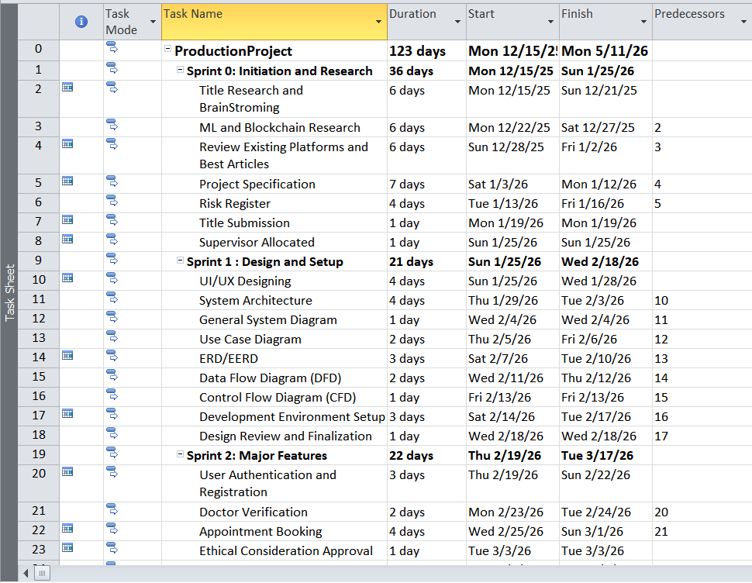

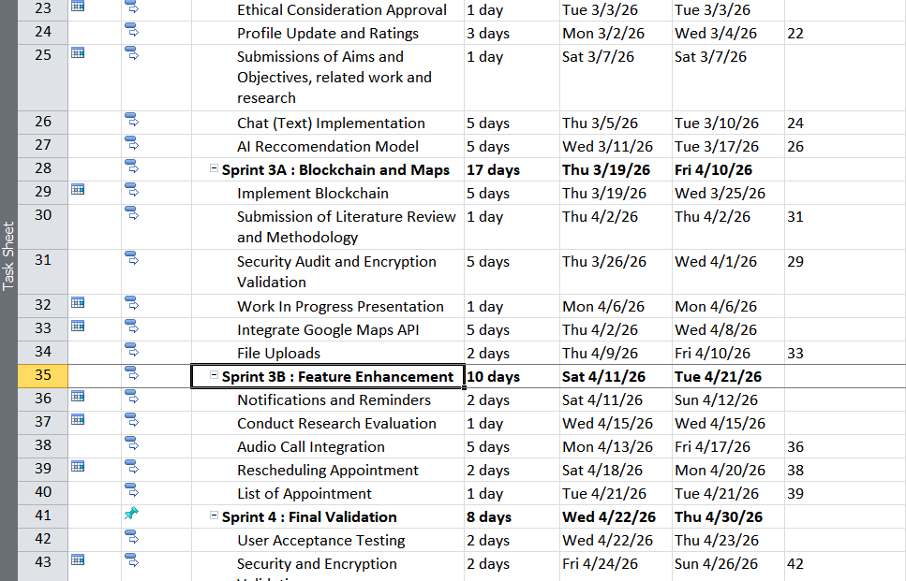
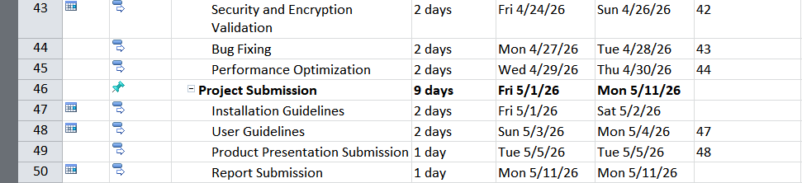
Figure : Task Sheet





Figure : Gantt Chart

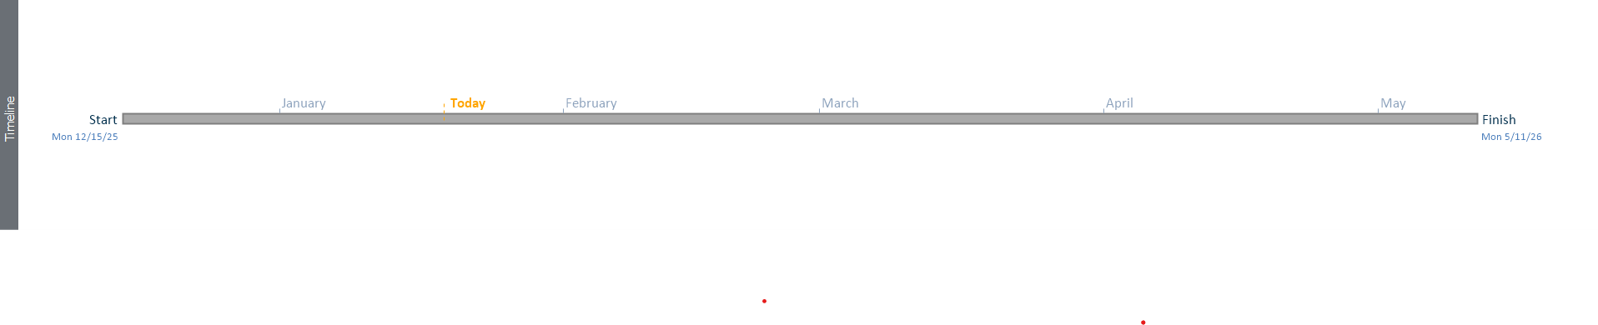
Figure : Timeline

Methodology:
This project adopts the Agile Scrum methodology for developing the healthcare platform within 12 weeks. This choice is backed by the reference and evidence from similar health care application. A telemedicine service employed Scrum to successfully deliver a complete service flow within the time period of eight weeks (Bin et al., 2021). Similarly, the integration of Machine Learning algorithms requires iterative refinement and continuous testing (Abrahamsson et al., 2002). Blockchain implementation in healthcare demands incremental security validation which cannot be accommodated by traditional Waterfall methods(Hasanova et al., 2018). Agile is beneficial for integration of multiple technologies which requires multiple testing(Schwaber & Sutherland, 2020).

Resources
The hardware I require to complete my Project successfully:
- Laptop | - Smartphone

The software I require to complete my Project successfully:
- Microsoft Word | - MS Project | - Microsoft Powerpoint
- Microsoft Excel | - Git Hub | - React Native
- Git | - Flutter | - AWS
- Draw.io | - Python | - Postman
- Google Maps API | - Geo Location API | - Django
- PyCharm | - PostgreSQL | - MySQL
- Solidity | - MetaMask | - Android Studio
- FireBase | - VS Code | - Figma

Human Resource
I am working on my Project with the following people
Name: Dr. Rohit Raj Pandey | Role:  Module Leader  Supervisor
Initial Bibliography
Abrahamsson, P., Salo, O., Ronkainen, J. and Warsta, J. (2002). Agile Software Development Methods: Review and Analysis.
Al-Khasawneh, M.A., Faheem, M., Alarood, A.A., Habibullah, S. and Alzahrani, A. (2024). A secure blockchain framework for healthcare records management systems.
Bin, K.J., Higa, N., Silva, J.H. da , Quagliano, D.A., Hangai, R.K., Cobello-Júnior , V., Pereira, A.J.R., Carneiro-D’Albuquerque, L.A., Carrilho , F.J., Wen, C.L. and Ono , S.K. (2021). Building an outpatient telemedicine care pilot using Scrum-like framework within a medical residency program. Science Direct.
Hasanova, H., Baek, U., Shin, M., Cho, K. and Kim, M.S. (2018). A survey on blockchain cybersecurity vulnerabilities and possible countermeasures.
Hassan, B.M. and Elagamy, S.M. (2025). Personalized medical recommendation system with machine learning. Neural Computing Applications.
Iqbal, T., Masud, M., Amin, B., Feely, C., Faherty, M., Jones, T., Tierney, M., Shahzad, A. and Vazquez, P. (2024). Towards Integration of Artificial Intelligence into Medical Devices as a Real-Time Recommender System for Personalised Healthcare: State-of-the-Art and Future Prospects.
Li , Y.H., Li, Y.L., Wei, M.Y. and Li, G.Y. (2024). Innovation and challenges of artificial intelligence technology in personalized healthcare.
Schwaber, K. and Sutherland, J. (2020). The Definitive Guide to Scrum: The Rules of the Game. The Scrum Guide.

‌
‌
‌

